The Analysis of Dallas Resident’s Preferences among Dallas Cowboys, Dallas Mavericks, and Texas Rangers

MKT 6309.0W1

Final Project

Group 2

Allison Gordon

Sashank Ketavarapu Srinivas

Deepak Sivaraman

Ramkumar Sreeram

Yu-Min Wang

Contents

Problem Definition

Research Design

Questionnaire Design

Sample Summary

Descriptive Statistics

Data Analysis

Strategic Implications & Managerial Recommendations

# Problem Definition

This survey is going to evaluate residents’ preferences among Dallas Cowboys, Dallas Mavericks, and Texas Rangers, which represents the NFL (football), NBA (basketball), and MLB (baseball) teams in Dallas area. Any one of the three teams could be our client; however, we will put more focus on the Dallas Cowboys in this report, and we are researching for the client on what separates their fans from the fans of the other two teams. The client wants to compare their brand image versus other major sports in Dallas and see what types of fans are connected to each sport. This can help them determine where they stand among Dallas sports in terms of popularity and demographics and can help them further understand who watches and doesn’t watch the games.

We set out to understand the following research questions:

1. Is there any difference in the preference, money spent, and time spent of the Dallas Cowboys in comparison with the other two major teams in Dallas?
2. Which demographic factor(s) is significant in deciding resident’s attendance and preference of Cowboys games?
3. What are the positive and negative factors in deciding preferences of a sports team? Is there any regression model to determine resident’s preference?

# Research Design

We went with descriptive research for our project because a survey is a quick and cheap way to get responses. Had we had more time for this project, it would have been interesting to use other types of research like focus groups to get an even deeper understanding of the consumers that surround the Dallas sports market. However, for the purpose of our project, a cross-sectional descriptive research design allowed us to describe the population at one current point in time by asking questions about preferences and demographics.

Our population consists of the entire population who live in or around Dallas, which is a huge population due to Dallas being such a large city. Therefore, sampling is useful for our project. We wanted to get a sampling frame that was as close to the population as possible. However, the most convenient way for us to get samples was through convenience sampling.

We used convenience sampling for our sampling frame by asking our fellow classmates and friends and family to fill out the survey. Within the convenience sampling technique, we also used a snowball effect where we asked friends to fill the survey out, and then they asked their friends. With this, we ended up with a total of 83 responses, which was a good amount for our sampling purposes. However, we realize that this type of sampling could be biased and that our data is limited. We can only make generalizations about our entire population due to the possibility that our sample is not represented of the whole population.

# Questionnaire Design

We designed our questionnaire on paper before we took it to Qualtrics. We wanted to include different ways of asking questions to make sure we received accurate results. We used many different question designs in our survey.

Our first three questions are Likert questions where customers can rate the question from strongly disagree to strongly agree. We then asked some preference questions using a graphic rating scale where users can rate their preferences between 0 and 100.  This type of question is good to measure emotional responses.

In order to make a regression model of preference, we needed to determine the predictors. We have collected secondary data, and from previous questionnaires, we found three factors that have been effective in surveying the preference of a sports team : Team Performance, Star Players, and Interactions with Fans. From Case 3.1 of Marketing Research by Naresh Malhotra (6th edition), we decided to add in a 4th factor as well: Community Service. These 4 factors, along with preferences, appear in the questionnaire as Q4-Q18 for each team.

Then we used constant sum questions to ask each respondent’s willingness to allocate the fixed money and time, e.g. $100 and 100 hours, among the 3 teams. This is question Q19-Q24.

Then in Q25, we ask a special question about people’s attendance of Cowboys games. This question is asking people’s action, not just preference or willingness.

The last questions we included were demographic questions. These questions were important to us because we wanted to see if we could segment the fans for each sport based on their demographics. These questions are asked at the bottom of our questionnaire because they are a little more personal. The demographics we asked for were gender, age, race, marital status, household size, level of education, employment and income.

We did not do a pretest with a sample, but the five of us went through the survey multiple times before we submitted the final one to Qualtrics. We noticed a couple of double-barreled questions that needed to be split in two. We also wanted to make sure we did not have any loaded questions toward the Dallas Cowboys in our preference questions. We also checked our demographics to make sure there was not any overlap between categories. Once we were satisfied, we put out our questionnaire to our sampling frame.

**Sample Questions on Preferences**

Please indicate the extent to which you agree or disagree with each of the following statements using the guide below:

        5: Strongly Agree

        4: Agree

        3: Neither Agree nor Disagree

        2: Disagree

        1: Strongly Disagree

Q1. I am a fan of the Dallas Cowboys

1 2 3 4 5

Q2. I am a fan of the Dallas Mavericks

1 2 3 4 5

Q3. I am a fan of the Texas Rangers

1 2 3 4 5

Q4. Please indicate your preferences about the three teams from 0 to 100, where 100 represents most preference and 0 represents the least :

* Cowboys
* Mavericks
* Rangers

Q7. Please Indicate your preferences about the Team Performance from 0-100, where 100 represents the most satisfaction and 0 represents the least:

* Cowboys
* Mavericks
* Rangers

Q10. Please indicate the extent you love the Star Players in each team, where 100 represents your most love and 0 represents the least:

* Cowboys
* Mavericks
* Rangers

Q13. Please indicate your satisfaction about the Community Service/Charity sponsored by each team, where 100 represents your most satisfaction and 0 represents the least:

* Cowboys
* Mavericks
* Rangers

Q16. Please indicate your satisfaction about the interactions with Fans of each team, where 100 represents your most satisfaction and 0 represents the least:

* Cowboys
* Mavericks
* Rangers

Q19. If you have $100 budget to spend on the three teams, how would you allocate your expenditure?

* Cowboys
* Mavericks
* Rangers

Q22. If you have 100 hours to spend in watching the games of the three teams, how would you allocate your time

* Cowboys
* Mavericks
* Rangers

Q25. Do you attend Dallas Cowboys games?

* No
* Yes

**Sample Questions on Demographics**

Q26. What is your gender?

* Female (0)
* Male(1)

Q27. What is your age?

* 21-30 (1)
* 31-40 (2)
* 41-50 (3)
* 51-60 (4)
* 61-70 (5)

Q28. What is your race?

* White (1)
* Asian or Pacific Islander (2)
* Hispanic/Latino (3)
* Black or African American (4)
* Other (5)

Q29. What is your marital status?

* Single, never married (1)
* Married, or domestic partnership (2)
* Separated (3)
* Divorced (4)
* Widowed (5)

Q30. What is your household size?

* 1
* 2
* 3
* 4
* 5
* 6 or more (6)

Q31. What is the highest level of education?

* High school graduate, diploma (1)
* Some college credit, not degree (2)
* Associate degree (3)
* Trade/technical/vocational training (4)
* Bachelors (5)
* Masters (6)
* Doctorate (7)

Q32. What is your income?

* 0 (1)
* 1-20000 (2)
* 20001 – 40000 (3)
* 40001 – 60000 (4)
* 60001 – 80000 (5)
* 80001 – 10000 (6)
* 100001-120000 (7)
* 120001 – 140000 (8)
* 160001-180000 (9)
* More than 200000 (10)

# Sample Summary

**Sample Size: n=83**

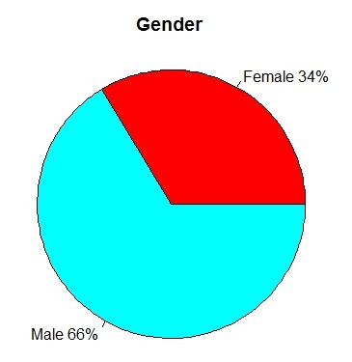**A picture containing vector graphics

Description generated with high confidence**

**A close up of a logo

Description generated with high confidence**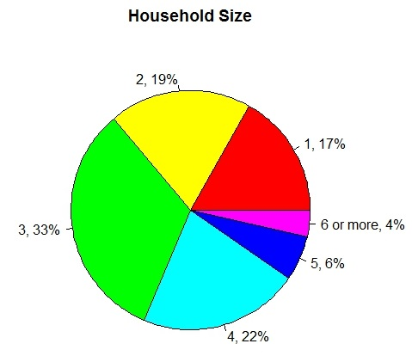

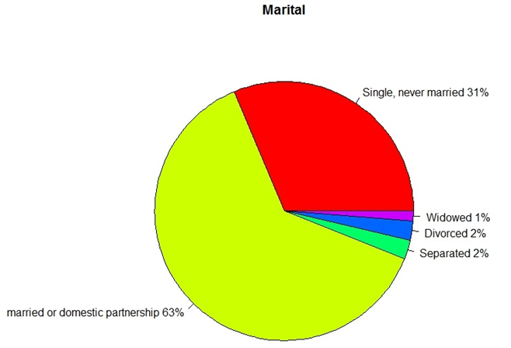

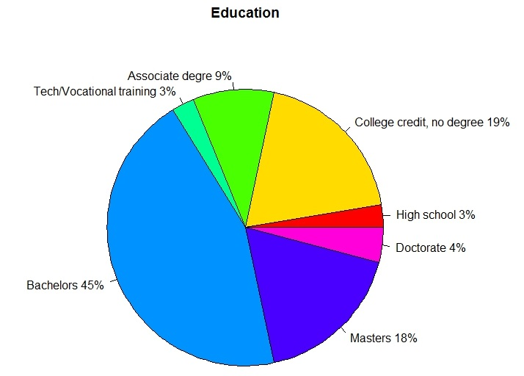

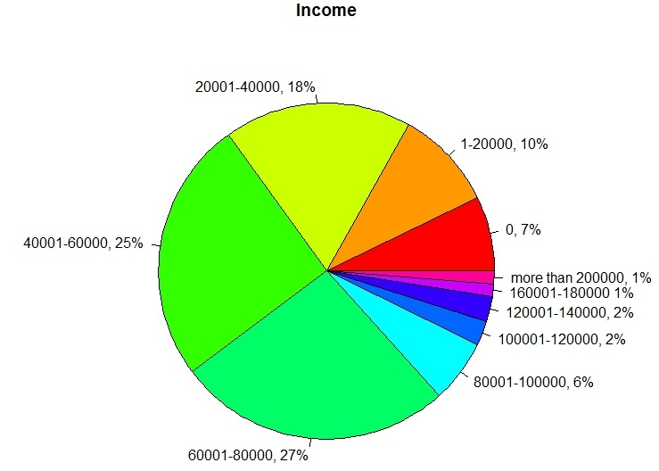

# Descriptive Statistics

Below is the average preferences of 3 teams and satisfaction level of 4 factors.

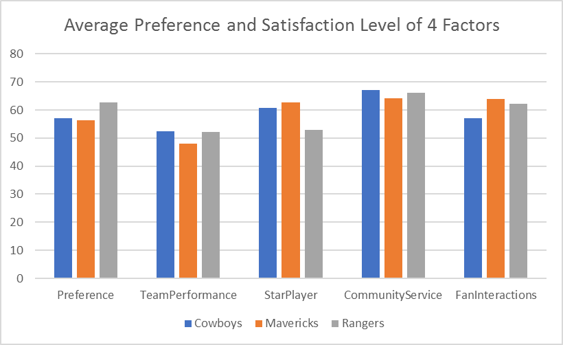

The following shows people’s willingness to allocate money and time among three teams.

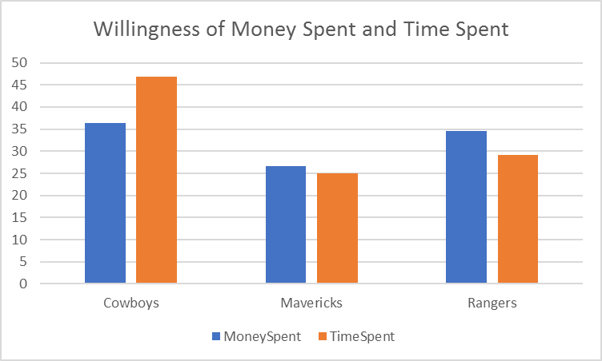

# Data Analysis

Our first research question was to compare the preference of the Dallas Cowboys to the Dallas Mavericks and the Texas Rangers. To understand the differences in brand preferences, we did ANOVA tests on the preferences between the three teams including comparing the mean amount of money people want to spend on each time and the time they want to spend on each team.

**1st Question Analysis**

First, we focused on the overall preference for the three teams. We have surveyed the data in such a way that Preference is represented as a numeric measure from 0 to 100 where 0 is the least and 100 is the max.

Anova: Test of Means

**µ1: Mean preference of Dallas Cowboys  
  
µ2: Mean preference of Dallas Mavericks  
  
µ3: Mean preference of Texas Rangers**  
  
Ho: µ1 = µ2 = µ3 H1: At least two means differ

Alpha = 0.05

A close up of a white background

Description generated with high confidence

Conclusion: At alpha=0.05% significance level, we can say that Mean preferences for all the three teams are the same and don’t differ from each other because p-value = 0.370.**We cannot reject the H0 that people have equal preference with respect to the three teams.**

The boxplot supports the conclusion:

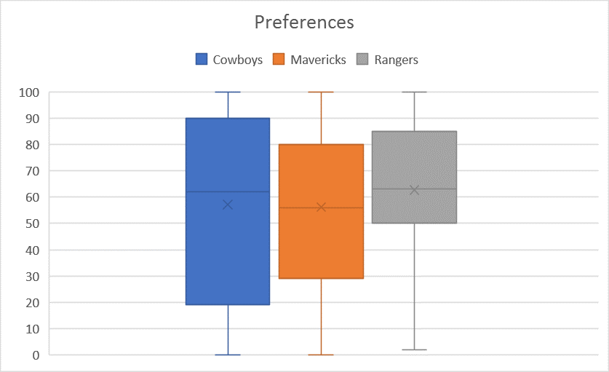

In the questionnaire we have also asked the willingness of money spent in a constant sum question. We can do the same ANOVA on money spent (Q19-Q21) among the three teams:

**A screenshot of a cell phone

Description generated with high confidence**

**For the willingness of money spent, we cannot reject H0 that people have equal amount of money spent with respect to the three teams. (p-value=0.129)**

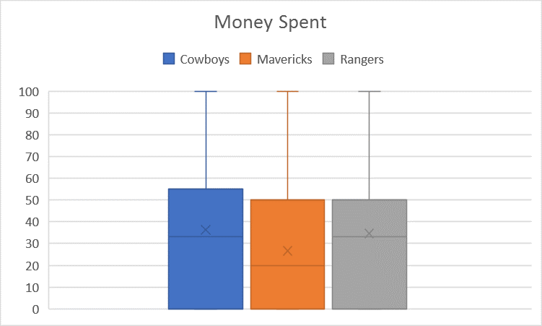

The boxplot also does not show much difference in the willingness of money spent among three teams.

In the questionnaire, we have also asked the willingness of time spent in a constant sum question. We can do the same ANOVA on time spent (Q22-Q24) among three teams:

**A screenshot of a cell phone

Description generated with very high confidence**

**As for hours spent, because p-value=3.43E-05, we can reject H0 and accept H1 that at least two teams differ in hours spent.**

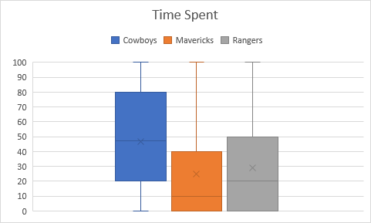

**The boxplot shows people like to spend more time on Cowboys in comparison with the other two teams.**

**2nd Question Analysis**

Our next research question pertained to looking for important demographic factors that have a relationship with attendance of Cowboys games. We did a few different chi-square tests and t tests to figure out if there is a difference in genders, ages, and income, etc.

Q1: To find whether the there is any relation between “Q25: Do you attend Dallas Cowboys games?” and “Q26: gender”?

These are 2 categorical variables. So we are doing a chi-square test:

> chisq.test(surveyTable$Q25, surveyTable$Q26)

Pearson's Chi-squared test with Yates' continuity correction

data: surveyTable$Q25 and surveyTable$Q26

X-squared = 5.4864, df = 1, p-value < .01916

**Interpretation:**

Let us consider the Null Hypothesis = H0 : the two variables are independent (there is no relationship between attending Dallas Cowboys games and gender).

Alternate Hypothesis: H1 = the two variables are not independent (there is a relationship between attending Dallas Cowboys games and gender).

From the results of the chisquare test we can see that the p-value is .01916 which is less than 0.05(significance level of 0.05). Therefore, we reject the null hypothesis that the two variables are independent and accept the alternate hypothesis that being male or female have an effect on whether they attend Cowboys games or not.

For every demographic factor(Q26-Q32), we make a chi-square test with attendance of Cowboys games(Q25) and get the following table:

|  |  |  |  |  |  |  |  |
| --- | --- | --- | --- | --- | --- | --- | --- |
|  | Q26: Gender | Q27: Age | Q28: Race | Q29: Marital | Q30: HHsize | Q31: Education | Q32: Income |
| p-value | 0.01916 | 0.5111 | 0.6285 | 0.3273 | 0.503 | 0.5408 | 0.7059 |

We find only gender has a relationship with attendance of Cowboys games.

Q2. To find whether male and female have equal preference in Dallas Cowboys.

> t.test(surveyTable$Q4[surveyTable$Q26 ==0],surveyTable$Q4[surveyTable$Q26 ==1])

Welch Two Sample t-test

data: surveyTable$Q4[surveyTable$Q26 == 0] and surveyTable$Q4[surveyTable$Q26 == 1]

t = 0.40979, df = 59.868, p-value = 0.6834

alternative hypothesis: true difference in means is not equal to 0

95 percent confidence interval:

-13.23753 20.05830

sample estimates:

mean of x mean of y

59.42857 56.01818

**Interpretation:**

Let us consider the Null Hypothesis = H0 : No difference in preference level in Dallas Cowboys(Q4) between male and female (means are equal)

Alternate Hypothesis = H1 : There is a difference in preference level (Q4) between male and female (true difference in means is not equal to 0).

From the results of the t-test we can see that the p-value is 0.6834 which is greater than 0.05 (significance level of 0.05). Therefore, we fail to reject the null hypothesis that there is no difference in preference level (Q4) between male and female.

**Thinking:** This analysis leads us to an interesting question: why does gender have a relationship with attendance but has no difference in deciding preference level? We found that both females and males say they are fans of Cowboys(in Q1) or that they have a high preference on Cowboys(in Q4), but there are no females attending the Cowboys games (in Q25) while only males attend the games. This means that saying “I like you” is one thing but “I attend” is another thing, especially for women.

Q3. To find whether age groups(Q27) 21-30(1) and 31-40(2) spend the same amount of money(Q19) on Dallas cowboys.

> t.test(surveyTable$Q19[surveyTable$Q27 ==1],surveyTable$Q19[surveyTable$Q27 ==2])

Welch Two Sample t-test

data: surveyTable$Q19[surveyTable$Q27 == 1] and surveyTable$Q19[surveyTable$Q27 == 2]

t = -0.67387, df = 70.651, p-value = 0.5026

alternative hypothesis: true difference in means is not equal to 0

95 percent confidence interval:

-22.21330 10.99225

sample estimates:

mean of x mean of y

35.60000 41.21053

**Interpretation:**

Let us consider the Null Hypothesis = H0 : No difference in amount spent on Dallas Cowboys(Q19) between the age groups(Q27) 21-30(1) and 31-40(2) (means are equal)

Alternate Hypothesis = H1 : There is a difference in amount spent on Dallas Cowboys(Q19) between the age groups(Q27) 21-30(1) and 31-40(2) (true difference in means is not equal to 0).

From the results of the t-test we can see that the p-value is 0.5026 which is greater than 0.05(significance level of 0.05). Therefore, we fail to reject the null hypothesis that there is no difference in amount spent on Dallas Cowboys(Q19) between the age groups(Q27) 21-30(1) and 31-40(2).

**3rd Question Analysis**

Our final research question focuses on what makes fans love the Cowboys, and how can the Cowboys use that information to gain a higher preference?

We assume this regression model: Y = Intercept + b1X1 + b2X2 + b3X3 + b4X4

Dependent Variable(Y): Preference for Dallas Cowboys

Independent Variables(X): respondent’s satisfaction level on Team Performance, Love for the star players, Community Service, Interactions with fans  
  
First we need to check if there is collinearity between the independent variables. The following collinearity diagnosis says there is no collinearity because all CI<30.

A screenshot of a social media post

Description generated with very high confidence

A screenshot of a cell phone

Description generated with very high confidence  
  
F- Stat = 36.41 and P- Value ~ 0. Overall the model is good.  
  
Adjusted R-Squared = 0.63 which is a good amount of variation explained in Team’s preference by Team Performance, Love for the star players, Community Service, Interactions with fans.  
  
**Predicted Preference for cowboys = 12.02 + 0.7697*Team’s Performance + 0.2413 *Love for Star Players – 0.4077*Community Service + 0.3062*Interaction with fans**  
  
**Interpretation:**  
1. A one point increase in Community Service satisfaction has a negative impact of 0.4077 points decrease in Team’s Preference among people keeping others constant. On average, Dallas Cowboys has 67 points with respect to community service.   
  
2. Team’s Performance has the highest impact in Team’s preference. A one point increase in Team’s performance has an almost 0.8 points increase in Team’s preference which is a huge impact.

Note: We make the same regression models on Mavericks and Rangers, finding the coefficient of Community Service/Charity is still negative while the other predictors positive, in spite of the R-squared of these two teams being 0.50 and 0.45.

A screenshot of a cell phone

Description generated with very high confidence

A screenshot of a cell phone

Description generated with very high confidence

# Strategic Implications and Managerial Recommendations

In this research, we take Dallas Cowboys as our target and get the following strategic implications for it:   
  
1. Community Service is a good-will but people’s choice has a negative impact on it. On average, Dallas Cowboys has the highest point in community service, 67 points vs. Mavericks 64 and Rangers 66, and a 20-point reduction will give almost an 8 point increase (-20*-0.4= 8) on average in Team’s preference among people.  
  
Recommendation: Spending on charity can be reduced and used for scouting, training, fitness etc.  
  
2. To increase Team’s preference among people for Dallas Cowboys, Team’s performance has to be improved which is the maximum impact for preference.   
  
Recommendation: Extensive training for players, pulling in experienced coach, nutritious supplements and healthy lifestyle, player motivation,…etc.

3. Gender has relationship with attendance of Cowboys games but gender cannot tell the difference of preference. That is because those women who like Cowboys do not attend the games. Only men attend Cowboys games in this survey.

Recommendation: It needs to be further investigated about the reasons behind this.

4. There is no significant difference in the preference of three teams, and no difference in the willingness of money spent on the three teams. But people are willing to spend more time on Cowboys in comparison with the other two teams. Recommendation: Cowboys can take the advantage of this willingness to figure out some competitive strategy.